**Part 1: SDG Selection and Problem Definition**

1. **SDG Selection**:
   * **SDG 3: Good Health and Well-Being** focuses on ensuring healthy lives and promoting well-being for all at all ages.
2. **Problem Definition**:
   * **Problem**: In many rural areas, vaccination rates are low due to limited access to healthcare services. This project will focus on tracking vaccination coverage and identifying areas where additional healthcare resources are needed to improve access.
   * **Objective**: Develop a data-driven solution to monitor vaccination rates, identify gaps in coverage, and provide insights to healthcare providers for better resource allocation.

**1. Entities and Attributes**

* **Location**
  + **LocationID (Primary Key)**
  + **LocationName**
  + **Address**
  + **Region**
  + **ProviderID (Foreign Key)**
* **Provider**
  + **ProviderID (Primary Key)**
  + **ProviderName**
  + **ContactInfo**
  + **LocationID (Foreign Key)**
* **Vaccine**
  + **VaccineID (Primary Key)**
  + **VaccineName**
  + **VaccineType**
  + **Manufacturer**
* **Vaccination**
  + **VaccinationID (Primary Key)**
  + **PatientID (Foreign Key)**
  + **VaccineID (Foreign Key)**
  + **ProviderID (Foreign Key)**
  + **DateAdministered**
* **Appointment**
  + **AppointmentID (Primary Key)**
  + **PatientID (Foreign Key)**
  + **ProviderID (Foreign Key)**
  + **DateScheduled**
  + **DateCompleted**
* **Visit**
  + **VisitID (Primary Key)**
  + **PatientID (Foreign Key)**
  + **DateOfVisit**
  + **LocationID (Foreign Key)**
* **Patient**
  + **PatientID (Primary Key)**
  + **FirstName**
  + **LastName**
  + **DateOfBirth**
  + **ContactInfo**
  + **Address**

**2. Relationships**

* **Location to Provider: Each Provider is associated with one Location.**
* **Provider to Vaccine: Each Provider can administer multiple Vaccines.**
* **Patient to Vaccination: Each Patient can have multiple Vaccinations.**
* **Vaccination to Vaccine: Each Vaccination involves one Vaccine.**
* **Vaccination to Provider: Each Vaccination is administered by one Provider.**
* **Patient to Appointment: Each Patient can have multiple Appointments.**
* **Appointment to Provider: Each Appointment is scheduled with one Provider.**
* **Patient to Visit: Each Patient can have multiple Visits.**
* **Visit to Location: Each Visit occurs at one Location**

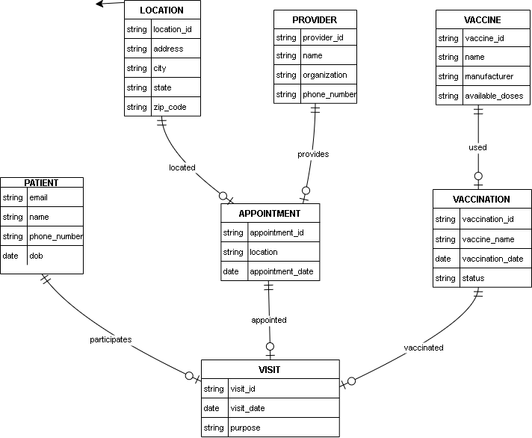

**PART 3: SQL SCRIPTS**

CREATE TABLE Location (

LocationID INT PRIMARY KEY,

LocationName VARCHAR(255),

Address VARCHAR(255),

Region VARCHAR(100),

ProviderID INT,

FOREIGN KEY (ProviderID) REFERENCES Provider(ProviderID)

);

CREATE TABLE Provider (

ProviderID INT PRIMARY KEY,

ProviderName VARCHAR(255),

ContactInfo VARCHAR(255),

LocationID INT,

FOREIGN KEY (LocationID) REFERENCES Location(LocationID)

);

CREATE TABLE Vaccine (

VaccineID INT PRIMARY KEY,

VaccineName VARCHAR(255),

VaccineType VARCHAR(100),

Manufacturer VARCHAR(255)

);

CREATE TABLE Vaccination (

VaccinationID INT PRIMARY KEY,

PatientID INT,

VaccineID INT,

ProviderID INT,

DateAdministered DATE,

FOREIGN KEY (PatientID) REFERENCES Patient(PatientID),

FOREIGN KEY (VaccineID) REFERENCES Vaccine(VaccineID),

FOREIGN KEY (ProviderID) REFERENCES Provider(ProviderID)

);

CREATE TABLE Appointment (

AppointmentID INT PRIMARY KEY,

PatientID INT,

ProviderID INT,

DateScheduled DATE,

DateCompleted DATE,

FOREIGN KEY (PatientID) REFERENCES Patient(PatientID),

FOREIGN KEY (ProviderID) REFERENCES Provider(ProviderID)

);

CREATE TABLE Visit (

VisitID INT PRIMARY KEY,

PatientID INT,

DateOfVisit DATE,

LocationID INT,

FOREIGN KEY (PatientID) REFERENCES Patient(PatientID),

FOREIGN KEY (LocationID) REFERENCES Location(LocationID)

);

CREATE TABLE Patient (

PatientID INT PRIMARY KEY,

FirstName VARCHAR(255),

LastName VARCHAR(255),

DateOfBirth DATE,

ContactInfo VARCHAR(255),

Address VARCHAR(255)

);